
Delaware Federation of Garden Clubs
Awards Application 2023 – 2025
October 1 - Due date for Yearbook application (two copies).
November 11 - Due date for State Awards applications.
Other deadlines are detailed on the DFGC Awards Schedule Sheet
Mail (do not email) applications to State Awards Chair: Mary Williford, 24900 Magnolia Circle, Millsboro, DE 19966
E-mail: mewilliford@verizon.net Phone: (302) 934-6017
Award Name: Civic Achievements Award #2___________

Garden Club: Coastal Gardeners Number of Members: 30

Club President: Sandy Daniels, Mary Kunst Awards Chair: Cathy Veale, Jennifer Martin

Phone: Sandy - 203-788-3813, Mary - 301-318-4509 Phone: 302 598 3290

Email: Sandy - sbdsun@aol.com, Mary - mbkunst47@gmail.com Email: Cathymveale@gmail.com

The Awards application is limited to this cover sheet and three printed pages (front only), including photos. Exceptions include publications (e.g., books, pamphlets). Yearbooks and other award submissions may be stapled or spiral bound. Please submit one application per award category. Yearbook award applications should include two (2) copies of the yearbook.

Each application should provide (please number the paragraphs accordingly):
- New project? Yes or No.
- Beginning date and completion date.
- Summary and objectives of the project.
- Details regarding the involvement of club members and/or other organizations.
- Project expenses and means of funding.
- State continuing involvement of the club, including any follow-up or maintenance.
Please integrate:
- Photos with descriptions, if available.
- Landscape plan, if appropriate. (Does not need to be professionally drawn.)

FOR COMMITTEE USE
Club Name:
 First Place  Second Place  Third Place  Honorable Mention
Committee Comments: ________________________________________________________________

Forward to:



NGC for Category



CAR
-
SGC for Category

- New Project: No
- Beginning date and completion date. This is an ongoing project beginning 3 years ago.
- Summary and Objectives of the project.
Coastal Gardeners maintains the large planters at the entrances of the Beebe South Coastal Emergency Room and South Coastal Cancer Center, located at 32750 Roxana Road, Frankford, DE. Four large containers (2 at each entrance), were placed at the entrances to the Emergency Room and the Cancer Center. The planters with beautiful flowers and greens provide a colorful addition to the entrances, giving patients, family members and workers a welcoming, positive emotional visual experience, entering and exiting the facilities.
- Details about involvement of the club members.
Coastal Gardeners are responsible for the flower design and maintenance of the planters. The planters are reworked for spring/ summer and then again in the fall. In the spring, 3 members of Coastal Gardeners added both annuals and perennials plus additional soil and fertilizer to keep the planters in bloom throughout the summer. Another 3 members of the Garden club will update the planters with fall flowers and greenery which will keep the planters vibrant throughout the winter. Members of the committee took into consideration the sun, shade and wind factors as each pot experiences different exposure to weather. The containers are under an overhang and do not get any rainwater, so hand watering is done by Coastal Gardener members throughout the growing seasons. The club is working to have more water flow through the drip lines to help offset the time commitment involved with watering esp in the heat of summer. The plants did very well with help from the garden members. The club has received a lot of compliments from both medical staff as well as visitors commenting on how beautiful these pots are and how they help to enhance the entrances. In addition to rotating the plants in the spring and fall, seasonal decorations are also added as appropriate.
- Project expenses and funding for the event.
Coastal Gardeners provided the soil, fertilizer and seasonal plants, with a discount from Inland bays Garden Center. The garden club pays for all materials with the club funds. The spring plants and material cost was $450.00. Fall plants, pumpkins, and soil total cost was $350.00.

- What is the ongoing involvement of the club, including any follow-up or maintenance.
The plants will be rotated seasonally along with occasionally amended soil and fertilizing as needed. Weekly hand watering is done by garden members.

Enter photo’s here.
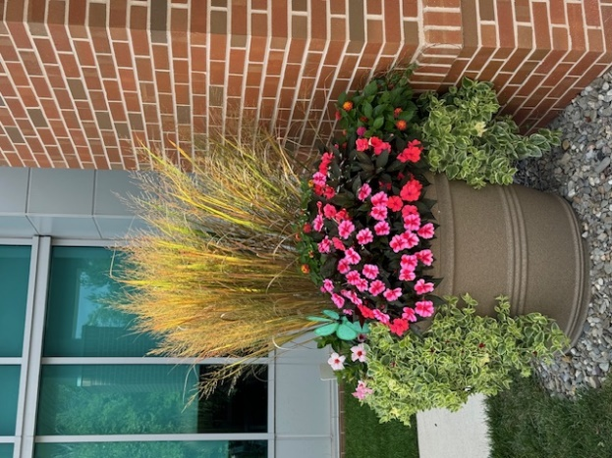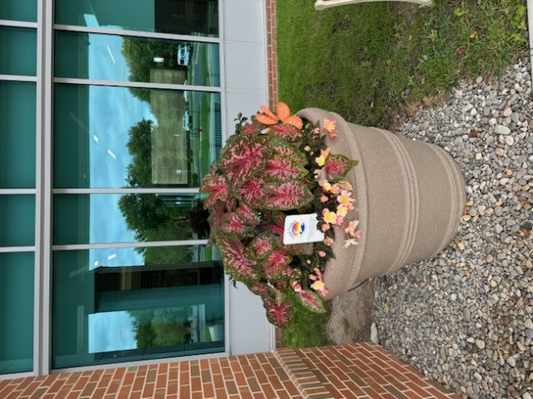
September 2024
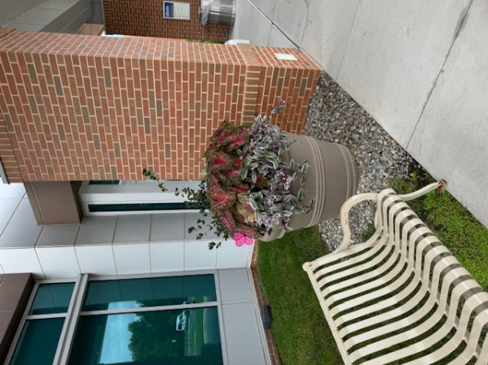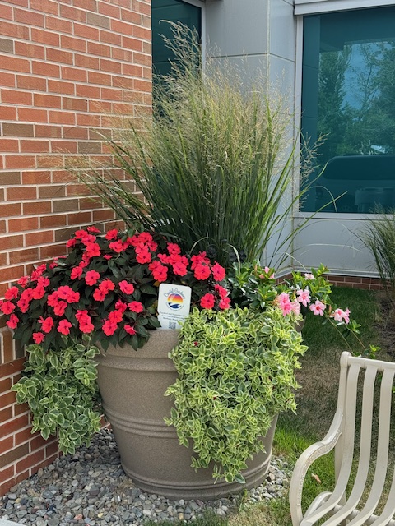
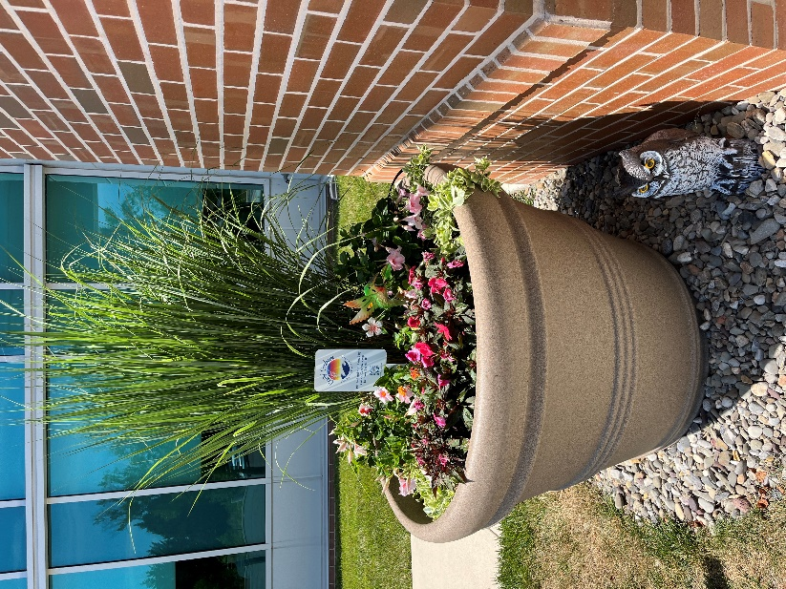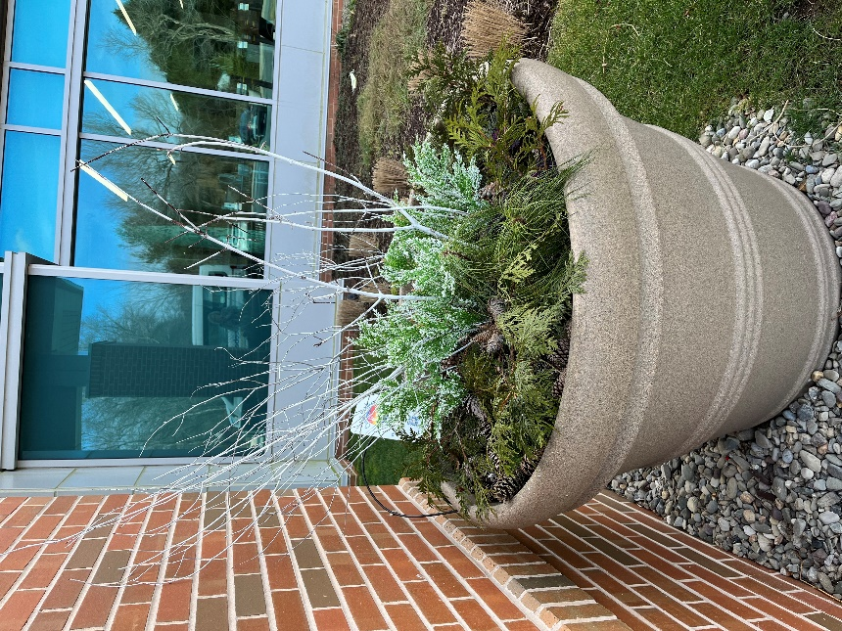
January 2024
June 2024

