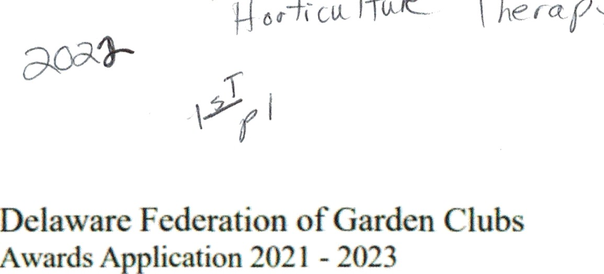

Application for State Awards to be submihed by Nov 11. Yearbooks are due Oct 1 Other deadline exceptions are detailed on the DFGC Awards Schedule Sheet.

Mail application to State Awards Chairman: Ma W II ford 2490LI Ma nol a C cle M Ilsbo o DE 19966

Email. me›v›lli!ord «' verizon net Phone f302j **934-6017**

Award Name: Horticulture Therapy Garden Club: Coastal Gardeners

Award #: 4A

Number of Members 41 ‹/

Club President: Sandy Daniels Phone: 203-788-3813 Email: [shdsun@aol.corJi](mailto:shdsun@aol.corJi)

Awards Chairman: Donna Buono Phone: 732-763-326 Email: [donnabuono2@gmail.com](mailto:donnabuono2@gmail.com)

Awards application form is limited to three printed pages*, except where noted on the DFGC Awards Schedule Sheet, front of pages only. No report covers, binders or plastic sheets are allowed. Please complete each topic listed below, if applicable. Use numbering that is indicated.

You may use the application form as a cover sheet only, if desired. If you choose to do this, do not add any protect information, photos, etc. to the application page except the information that is specifically requested. You may then add THREE full pages of project information, photos, etc. to your application.

* NOTE: If you add project information to the application page, it will count as one of the three pages in your application and you may add only TWO more pages.

Application form will not be returned. Exceptions: publications (books, CD/DVD). Copy the completed application for your files.

PLEASE complete each topic, if applicable. Use numbering below when completing the form.

1. New Project: Yes Beginning date: March 28, 2022 Completion date: April 27, 2022
2. Brief summary and objectives of project

The Roxana Senior CHEER center is located at 34314 Pyle Center Road, Frankford DE. The Director at that location is Sharice Franklin. This CHEER center provides daily physical and social welfare support to a rural population in southern Delaware. Sharice asked Coastal Gardeners to provide a hands-on gardening class for the mature adults who come to the center. The request came during last year's delivery at the December's project holiday of 160 gift bags. Coastal Gardeners project lead reached out to the Master Gardener who designed the program and donated the seed trays along with her time and other materials. This project gave the adults the experience to grow from seed to a take home plant. First event, in March, was learning about flower seeds, soil, and how to plant and grow lights. Second event was transplanting the seedlings into pots and preparing them for transport to home gardens in April.

1. Involvement of club members, other organizations, etc.

Certified Master Gardener, Penny Huth provided the guiding concepts, structure, and expertise for the program. She also led each session, explaining soil differences, how to plant and care for flower seeds (Marigolds; Zinnias; Cosmos) and how to grow them to seedlings for pot planting or planting in a home garden or flowerbed. Penny provided hands-on guidance with the Roxana Cheer adults in both the planting and transplanting events. First event - learning about flower seeds, soil, how to plant and grow lights was on March 28. Second event - transplanting the seedlings into pots and preparing them for transport to home gardens was on April 27.

Coastal Gardeners volunteer members were Mary DeHahn, Sally Scarangella, Cheryl Quirk, and Arleen lnyard. The club members prepared 15 Seed Planting Kits that included: (a) fully written instructions for seed planting and transplanting; (b) two peat pots; (c) a pressed paper egg carton;

(d) two packets of starter soil (one for the peat pots and one for the egg carton; (e) small plastic spoons for mixing and manipulating the soil as well as for use as ID markers on the peat pots and egg cartons; (f) a small plastic cup for mixing water in the starter soil. The club members worked hands on with all the participants during both the planting and transplanting events. They also checked in with the progress of the seedlings and provided clean up after each event.

The center location was not ideal for indoor starting of seeds (small north windows only) so a key element of the Seed Start/Transplant program was that Coastal Gardeners providing grow lights for the seedlings. The Roxana Cheer director and her assistant actively participated in working with the adults and supporting the care of the seedlings under the grow lights for the five weeks of germination and growth before transplanting to take-home pots. The Roxana Cheer staff provided the additional Seed Planting kits (eight of them) and coaching on how to plant the seeds to other Cheer adults who were not able to participate in the two events, so they were able to enjoy the program as well.

There were seven participated at each event that had dexterity, mobility, and cognitive challenges. One participant is blind. Each of them enjoyed individual attention from Penny and the club members in completing their planting and transplanting projects. The activities were successfully

geared toward the tactile pleasures of working with natural materials and experiencing the joy of tiny seeds growing into living plants. Of note, the gentleman who is blind told Penny that he remembered how individual plants felt during the transplanting program.

1. Project expenses and means of funding

The costs for Coastal Gardeners totaled $202.52. This Includes flower seeds, peat pots, egg cartons, coffee filters (to line transplant pots), pot saucers, disposable tablecloths, pot saucers, spray bottles, plastic spoons and cups, trowels, markers, starter soil, transplant soil, and grow lights. They selected organic and compostable materials whenever possible.

Materials paid for or donated by Master Gardener, and club members. The items were seedling trays, transplant pots, watering cans, trowels, paper towels, trash bags, Dusty Miller plants to anchor transplant pot arrangements. Printing program directions were provided. The Master Gardener and club members donated 17 hours for concept development, direction to club members on kit preparation, leading both two-hour events, travel time to get to the event location. The club members also donated 65 hours for the program concept preparation with Master Gardener, materials research and purchasing, planting kit design and assembly, staffing both two-hour events, travel time to get to the events.

1. Continuing involvement, follow-up, maintenance

The Coastal Gardeners' program team lead has met with the Master Gardener to conceptualize future gardening and horticulture programs for Roxana Cheer Center specifically for mature adults with physical or cognitive challenges as well as other Cheer Center adults. Club Members will be meeting with the Roxana Cheer director to discuss program participation and design—she has expressed an interest in ongoing programs. The director of the Ocean View Cheer Center has expressed interest in the Seed Starter/Transplant program for her venue, which is about 10 miles from the Roxana Center and serves a different population.

1. Attach or insert photos, digital photos and/or landscape plan (does not need to be professionally drawn).

Supplies and instructions, grown lights and start seed kit items

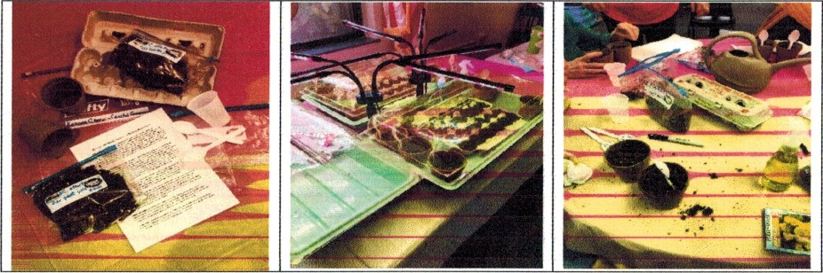

Director of CHEER Club members w”ith adults Penny explains seed depth to class

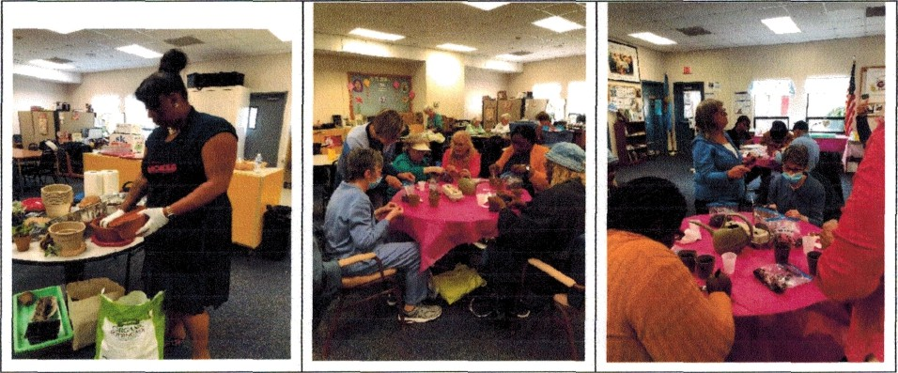

Getting the soil ready and planting the seeds

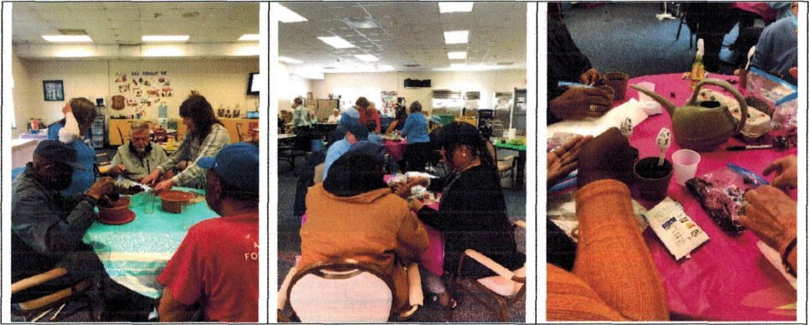

Transplanted into pots and watering

